Qiming Jin

11/18/2019

IT FDN 100 A Au 19: Foundations Of Programming: Python

Assignment 07

# Knowledge Document

## Assignment

Create a new script that demonstrates how Pickling and Structured error handling work.

## Steps

1. Create objFile AppData.dat in the local.
2. According to the template, create two functions according to realize the data storage and reading.

**def** save_data_to_file(objFile, lstCustomer):  
 objFile = open(**"AppData.dat"**, **"ab"**)  
 pickle.dump(lstCustomer, objFile)  
 objFile.close()

**def** read_data_from_file(objFile):  
 objFile = open(**"AppData.dat"**, **"rb"**)  
 objFileData = pickle.load(objFile) *# load() only loads one row of data.* objFile.close()  
 print(objFileData)

1. Get the ID and Name From user and then store it into a list object.

intId = int(input(**"Enter an Id: "**))  
strName = str(input(**"Enter a Name: "**))  
lstCustomer = [intId, strName]

1. Store the list object into a binary file by using the function save_data_to_file().

save_data_to_file(strFileName,lstCustomer)

1. Read the data from the file into a new list object and display the contents by using the function read_data_from_file().

read_data_from_file(strFileName)

1. Run the script in OS command/shell window and test if it works.

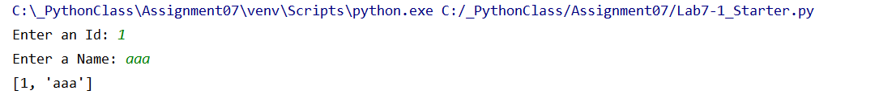

1. Check the data in text file.

